Easter Selfie Challenge!
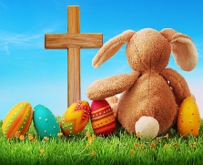
Family Fun!
T Unknown Author is licensed under CC BY
Complete the challenges—receive some Easter Eggs!!
To be completed by 2nd of April 2021
The following challenges takes us from Bethlehem to the resurrection of Jesus.
READ the verses given. REFLECT on it by completing task.
REMEMBER to take a Selfie!
1. READ—Luke 2 verses 6+7
REFLECT—find an object to represent a birth e.g. a doll wrapped in a blanket, make your own scene of the stable.
REMEMBER—take a Selfie!
2. READ—Choose one of your favourite miracles that Jesus performed and read it as a family.
REFLECT on it and discuss.
REMEMBER—take a selfie of you reading it with the Bible open on the chosen miracle and draw, or colour a picture related to the miracle.
3. READ—Matthew 26 vs 36
REFLECT—Jesus goes to Gethsemane and prays; sit in a garden or a park and pray, just as Jesus did.
REMEMBER—take a Selfie in the garden or park with some flowers in the background.
4. READ—Matthew 27 vs 32 (read more of this chapter if you have time).
REFLECT—Simon carried Jesus’ cross; be creative and make a cross from objects at home or take a walk to the cenotaph (if you’re in Lisvane) or to somewhere you know there’s a cross. REMEMBER—take a Selfie!
5. READ—Matthew 28 verses 1-7 (again, read more of this chapter if you have time.)
REFLECT—Jesus rose again! Jesus can help us to live with joy—shout “Jesus is Risen, Hallelujah.”
REMEMBER—take a Selfie of all of you celebrating that Jesus has risen—have a party!

When you have finished the Easter Challenge and I have received your photos I will then deliver some Easter Eggs to you!!
God showed His love by sending Jesus to die on the cross and John 15 verse 11 says “This is my command: love one another the way I loved you. This is the very best way to love.” (The Message) Therefore, when you have received your eggs, I would like you to give one of the eggs to a friend, or someone that you will be seeing over Easter and haven’t seen for a while. This is a way of showing God’s love to others.

Please send all photos to kidz@lisvanebaptist.com
OR What’s App them to me on 07825136988
ENJOY!! Nia
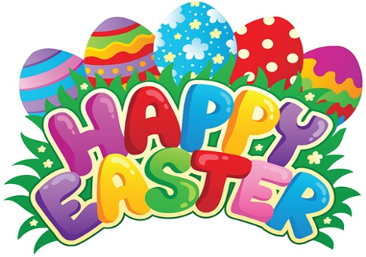
This Photo by Unknown Author is licensed under CC BY-SA-NC

